**Memory Representation of data types**

**Char**

char data types may be signed or unsigned. Size of char data type is 8 bit. Both signed and unsigned have different memory representation.

**Memory representation of unsigned char:**

**Unsigned char a = 7;**

In unsigned char all 8 bit is used as data bit **.**Binary equivalent of 7 is: 111**.**For 8 bit we will add 5 zero in the left side i.e. 00000111

**In the memory:**

[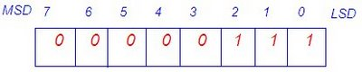](http://4.bp.blogspot.com/_uIwyaTjqYYw/SjxUlR4cn5I/AAAAAAAAA0U/oEvEiq__PAM/s1600-h/unsigned+char.bmp)

Here MSD stand for most significant digit and LSD list significant digit.

2. **Memory representation of signed char:**

1 bit: signed bit

7 bit: data bit

Char a = 7;  
 Note: In C, negative number is stored in the 2’s complement format.  
 Signed bit is 0: Number is positive.  
 Signed bit is 1: Number is negative.Binary equivalent of 7 is: 111  
 for 8 bit we will add 5 zero in the left side i.e. 00000111  
 **Memory representation:**

[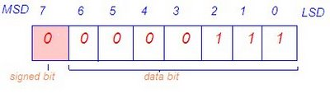](http://3.bp.blogspot.com/_uIwyaTjqYYw/SjxUlmp6CYI/AAAAAAAAA0c/tdJR_rOCTVk/s1600-h/signe+p+char.bmp)

(2) Memory representation of **char** a=-7;

Binary equivalent of 7 is 111.for 8 bit we will add 5 zero in the left side i.e. 00000111.since a is negative number so it will store in the memory in the 2’s complement format

1’s complement of a: 11111000

+ 1

____________

2’s complement of a: 11111001

**Memory representation:**

[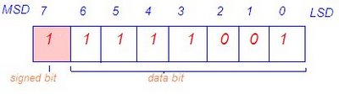](http://2.bp.blogspot.com/_uIwyaTjqYYw/SjxUlzmY0fI/AAAAAAAAA0k/5cdXQT7LPDk/s1600-h/signe+n+char.bmp)